BATTLE OF THE BADGES
SOFTBALL TOURNAMENT
SEPTEMBER 18th & 19th, 2015

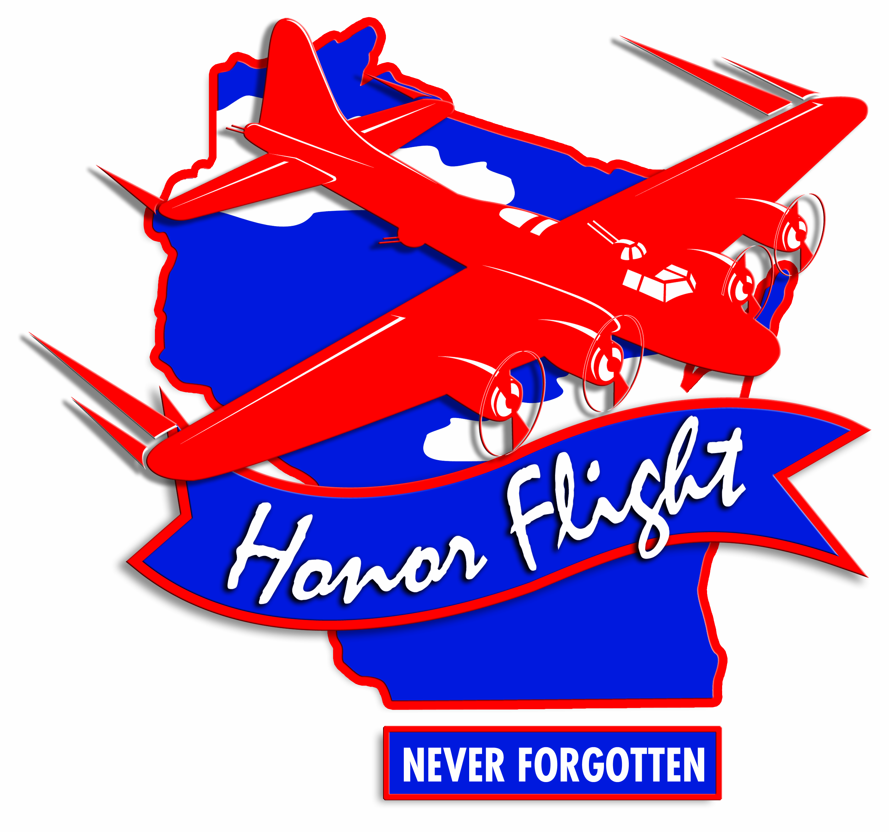

The Honor Flight has brought tens of thousands of veterans to Washington D.C. to visit the memorials that stand in their honor. Some veterans have waited 60+ years to visit their memorial and right now is our chance to bring it home. In 2014, the Battle of the Badges Tournament raised $4,000, supporting eight veterans on their trip to Washington D.C.
Join us on September 18th and 19th, 2015, as the Marathon County Sheriff’s Department is proud to host its second annual Battle of the Badges Softball Tournament. Our central Wisconsin law enforcement family is excited to battle it out on the fields of Sunnyvale in a 12 team, 3 field softball tournament. We invite the community to come out for this free family event to cheer on your favorite team for a good cause. For registration or more information on the event, send an email to hannah.becker@co.marathon.wi.us
All proceeds will benefit the local chapter, Never Forgotten Honor Flight, as the Marathon County Sheriff’s Department strives to always commemorate those who stand strong for our community, our freedom, and our country.
BATTLE OF THE BADGES SOFTBALL
September 18th & 19th, 2015

Softball Tournament Registration Form
Registration Deadline – September 6th, 2015
CONTACT INFORMATION

Department_________________________________________________________________

Department Representative Name ________________________________________________
Address ____________________________________________________________________
City ___________________________________ State _________ Zip Code ______________
Home Phone ______________________________ Work Phone ________________________
E-mail address ______________________________________________________________
Additional T-Shirts XS_____S_____M_____L_____XL_____2X_____3X_____4X_____
TEAM MEMBERS AND T-SHIRT SIZES
1 | 11
2 | 12
3 | 13
4 | 14
5 | 15
6 | 16
7 | 17
8 | 18
9 | 19
10 | 20

PAYMENT AND REGISTRATION
Please make sure to fill in the appropriate team member sections above.
Return this registration form with a money order or check made payable to Marathon County Deputy Sheriff’s Association. The fee is $25 per player. A team needs a minimum of 10 players. All registrations are accepted on a first come first serve basis and the first twelve teams that register will be in the tournament. Payments are not refundable. Along with your registration and payment, please include ‘Tournament Information/Accommodations’ signed by your Department Representative. ALL PROCEEDS AND FUNDS OF THE EVENT WILL BE FORWARDED TO THE ‘NEVER FORGOTTEN HONOR FLIGHT’.
Please send your registration and payment to Hannah Becker c/o Battle of the Badges, Marathon County Sheriff’s Department-Jail, 500 Forest Street, Wausau, WI 54403. Registration deadline is September 6, 2015.

BATTLE OF THE BADGES 2015
Tournament Information / Accommodations
- The Battle of the Badges Softball Tournament is scheduled for September 18th and 19th, 2015. The opening ceremony will start at 6:30 P.M. on Friday, September 18th, 2015. The games will start at 7:00 P.M. on Friday, September 18th and continue on Saturday, September 19th at 9:00 A.M. The tournament is being held at the Sunnyvale Softball Complex located in Wausau, Wisconsin. The first 12 teams to register will be accepted into the tournament. Teams need a minimum of 10 players on their team. Men will be required to use a wooden bat; they will be provided. ALL PROCEEDS AND FUNDS OF THE EVENT WILL BE FORWARDED TO THE ‘NEVER FORGOTTEN HONOR FLIGHT’.
- Tournament Fee: All participants are required to pay the individual tournament fee of $25 per player when registering for the softball tournament. Fee includes a T-shirt and rubber bracelet.
- If players, department members, or family members would like to purchase additional T-shirts, please indicate accordingly on the registration form. Cost per T-shirt is $15.
- Concessions are available on-site for participants and fans. Concessions will be provided by Boy Scout Troop 438 and Cub Scout Pack 438. No alcohol will be sold on the premises. Attendees may bring their own beverages.
- Confirmation: Applicants will receive a confirmation email or letter at the time of their acceptance. Your cancelled check may serve as a receipt. You will be notified if the softball tournament is full or if there is a problem with your application.
- Specific tournament information including schedule and game times will be emailed to each Department Representative one week in advance of the tournament.
- Refunds and Cancellation Policy: Battle of the Badges does not provide refunds. If your team cannot attend the tournament after registering, you forfeit your monies.
- Health and Accident Insurance: Battle of the Badges does not provide health and/or accident insurance.
- Weather Policy: In the event of extreme weather conditions, we reserve the right to cancel or postpone any part of the tournament for the safety of attendees and cannot provide a refund for any cancellation or postponement that is weather related. If a rain date is needed, there may be adjustments to the tournament format in an attempt to complete the tournament.
- Waiver and Release Liability: All players must sign a waiver and release form PRIOR to the date of the tournament. Once you have signed a waiver and release liability form, you will be given a rubber bracelet to be worn throughout the day.
I have read and accept all of the terms and conditions set forth for the registration process.

X___________________________ X______________
Department Representative Signature Date
BATTLE OF THE BADGES 2015
Waiver and Release of Liability
WAIVER AND RELEASE OF LIABILITY (READ BEFORE SIGNING)
In consideration of being allowed to participate in any way in the softball tournament related events and activities, the undersigned acknowledges, appreciates, and agrees that:
1. The risk of injury from the activities involved in this program is significant, including the potential for permanent paralysis and death, and while particular rules, equipment, and personal discipline may reduce this risk, the risk of serious injury does exist; and
2. I KNOWINGLY AND FREELY ASSUME ALL SUCH RISKS, both known and unknown, EVEN IF ARISING FROM THE NEGLIGENCE OF THE RELEASEES or others, and assume full responsibility for my participation; and
3. I willingly agree to comply with the stated and customary terms and conditions for participation. If, however, I observe any unusual significant hazard during my presence or participation, I will remove myself from participation and bring such to the attention of the nearest official immediately; and
4. I, for myself and on behalf of my heirs, assigns, personal representatives and next of kin, HEREBY RELEASE AND HOLD HARMLESS ‘BATTLE OF THE BADGES SOFTBALL TOURNAMENT PERSONNEL’ their officers, officials, agents, and/or employees, other participants, sponsoring agencies, sponsors, advertisers, and, if applicable, owners, and lessors of premises used to conduct the event (“RELEASEES”), WITH RESPECT TO ANY AND ALL INJURY, DISABILITY, DEATH, or loss or damage to person or property, WHETHER ARISING FROM THE NEGLIGENCE OF THE RELEASEES OR OTHERWISE.
I HAVE READ THIS RELEASE OF LIABILITY AND ASSUMPTION OF RISK AGREEMENT, FULLY UNDERSTAND ITS TERMS, UNDERSTAND THAT I HAVE GIVEN UP SUBSTANTIAL RIGHTS BY SIGNING IT, AND SIGN IT FREELY AND VOLUNTARILY WITHOUT ANY INDUCEMENT.

X__________________________________
Participant’s Signature

X__________________________________
Participant’s Printed Name

X__________________________________
Date Signed

